Cantilever Load testing machine
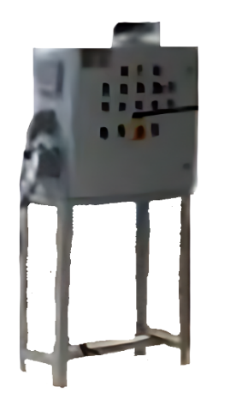
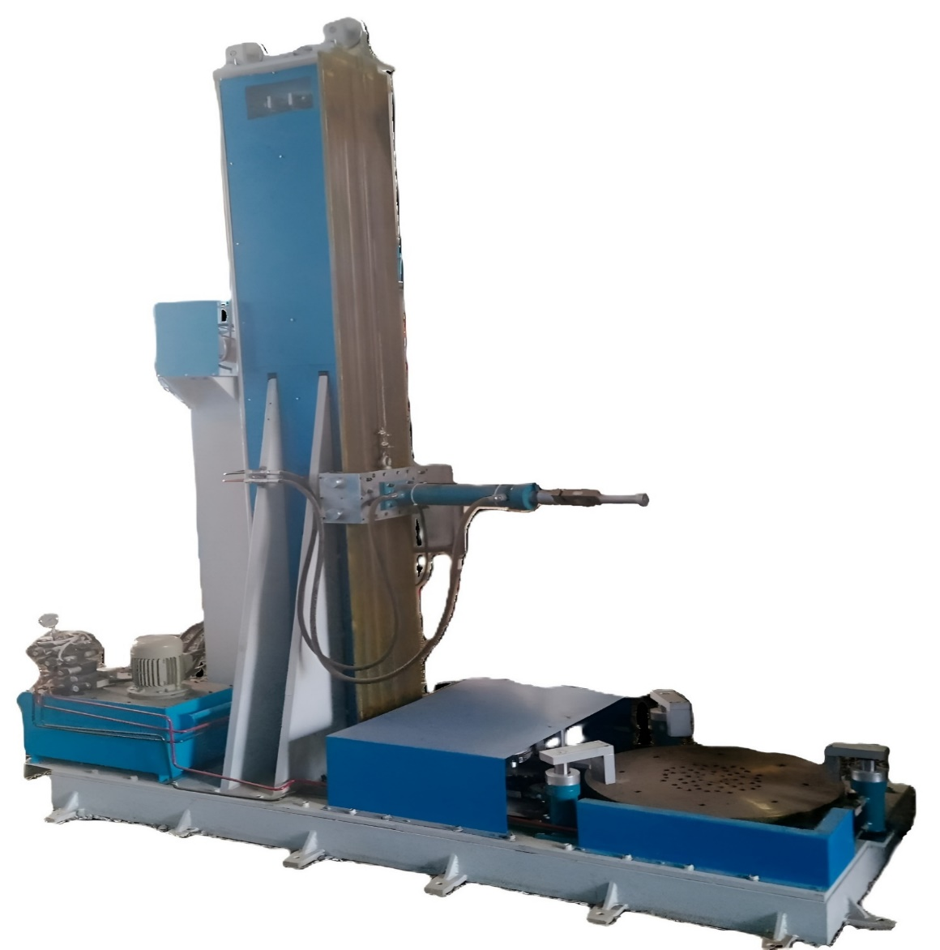

- Product Parameters:

Cantilever Load testing machine

Product Parameters | Cantilever Load testing machine
Operation | Hydraulic Operated System
Load Capacity | 2 Ton, 5 Ton and 10 Ton
Electrical Power Supply | 415 VAC, 50 Hz, 3 Phase
Machine Height | 4 meters to 8 meters
Insulator Height | 3 meters to 6 meters
Universal load cell Capacity | 2 Ton, 5 Ton and 10 Ton, least count: 0.1kg
Suitable for | Ceramic Insulator Testing
Applications | Load testing
Loading / Unloading | Manual operation

